Doubling Script Comparison

David Graves
Colorado State University Global
CSC507
Dr. Joseph Issa
August 7, 2025

Doubling Script Comparison
The following exercise was performed to see the difference in program execution using four different algorithmic solutions using both Linux shell script and Python. The basic task to perform was to read an existing file (file1.txt) that contains 1,000,000 rows of random numbers, double each original value, and write the new value in another file (newfile1.txt). The first script I used was a shell script in Linux, followed by three different algorithmic approaches using Python. Prior to running this experiment, I anticipated that the Linux shell might take longer than the subsequent attempts using Python script, and that of the three different Python versions the one that read the entire file into memory before processing might be faster. Having run all four samples, I turned up some surprising results and some not so surprising results as shown below.
Linux Shell Script – time to execute 44 seconds
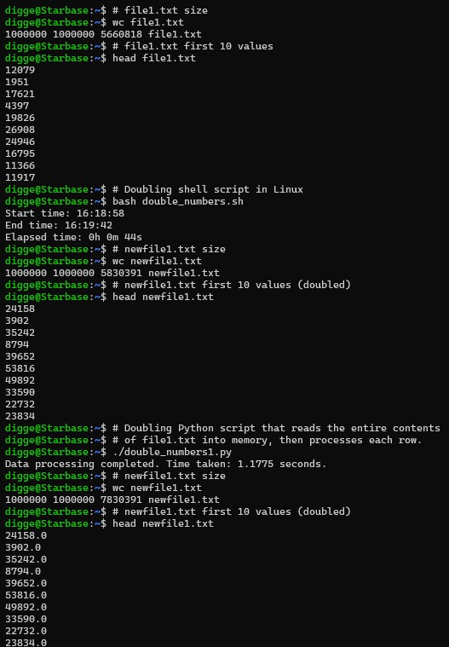
The program appears to run as expected and doubled the value from the initial file as shown using the ‘head’ function of both the previous and new files. This script took a decent amount of time to execute at 44 seconds and served as my baseline that I ran the Python examples against.
Python that reads entire file into memory then processes – time to execute 1.775 seconds
This Python program produced the same results as the Linux script by reading the entire contents of ‘file1.txt’ into memory and then processing each row to write to ‘newfile1.txt’. This was considerably faster than the Linux script and was not a big surprise since I was able to leverage Python’s built-in file handling capabilities to gain significant efficiencies.
Python that reads one row at a time then processes – time to execute 1.1912 seconds
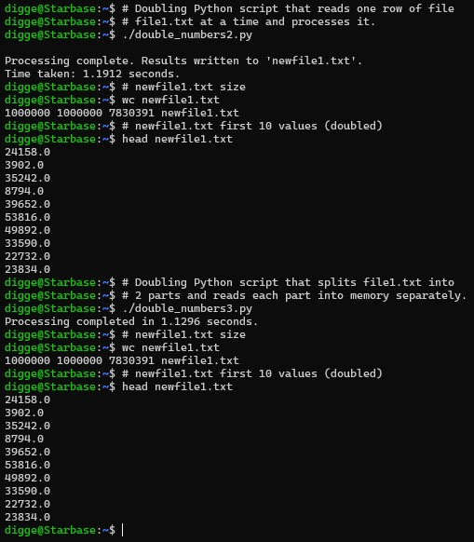
This version of the program also produced the correct results by reading each line individually and processing them one at a time. I’ll share a little more about this result in my final reflection, but this one was somewhat of a surprise in that it was faster than reading the whole file into memory. I didn’t anticipate that result and will share some thoughts on why this turned out like it did, after I show the final version of the algorithm I tested below.
Python that splits the initial file in 2, reads each part to memory then processes – time to execute 1.1296 seconds
This version also produced the correct results and did so in 1.1296 seconds, making it marginally better than reading the file in its entirety into memory before processing.
Reflection
In conclusion, the best method I’ve found to write a new file after reading an initial file with 1,000,000 rows and doubling each value was to have Python just read each line one at a time and process each one. As I had initially thought all three versions of Python returned the same results much faster than just using a Linux shell script. The surprise for me was that there wasn’t any value in reading the initial file into memory whether it was in one chunk or split into 2 smaller buckets. After doing a little bit of reading on the subject I found that since the initial file I was manipulating wasn’t very big, as shown below about 5.6mb, that all three Python approaches returned about the same result regarding execution time.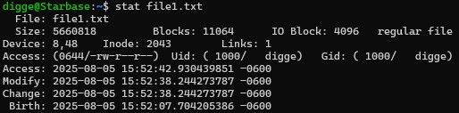
If I were dealing with a much larger initial file then reading it into memory in its entirety should produce better execution time results, but in this instance the additional overhead associated with reading the whole file into memory, thereby tying up more memory, doesn’t make sense and the best approach is the simpler one.

